**POWER BI EXAMPLES**

**How to install power bi desktop tool:**

**pre-requisites: win 8 or higher. 32bit or 64bit. 4 gb ram or higher**

**download link**: [https://aka.ms/pbisingleinstaller](https://aka.ms/pbiSingleInstaller)

Choose any one file from above link [either 32 bit or 64 bit] > download.

Double click above downloaded file > install > accept licensing terms > install.

(restart your computer)

**ITEM #1: HOW TO DESIGN POWER BI REPORTS [BASIC EXAMPLE - 1]**

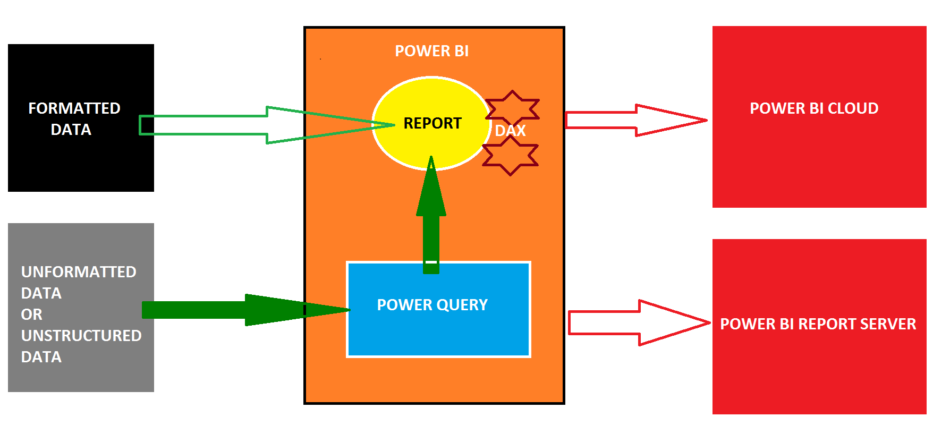

Step 1: windows apps > search > type : "**power bi desktop**" > click to launch power bi

then you see one welcome screen. Close this.

then we see one power bi designer interface.

**home** ribbon > **get data** > excel > browse "sales" excel file > select sheet > **load**.

this data is loaded into a **table** inside an internal power bi database: "**in-memory xvelocity veritpaq database**". This database is temporary, in memory.

step 2: to verify the imported table data:

from home ribbon > left side : veritical pane : 2nd button : **data**.

to go back to report screen : home ribbon > left side : veritical pane : 1st button

Step 3: how to design a basic **report** in power bi?

a power bi report can be generated from any data source (file, database, app...).

each power bi report can be divided into multiple "**pages**". Just like excel "sheets".

click @ page 1 > from visualizations pane (right) > select **treemap** visual (18th).

then one empty treemap visual is auto added to the canvas (white design window)

select the treemap from canvas (left: white screen)> from "fields" pane (right) > check the boxes @ *country*, *sale 2020*

Then select the treemap visual from the canvas (white screen) > expand the size.

Select treemap > below visualizations pane (middle window) > format button >

**Legend** : on: set text size [to control or highlight category] **data labels**: on: set text size [to report summary values = *total sales*] **category labels**: set text size [to report category text=*country* names

Purpose of Legend : To Highlight or Select the required Category Items (Country).

Each Category Item forms a "Data Point". [Box; Ex: Germany Data Point, India Data Point...]

**Step 4**: what are the options to save power bi report locally [in our computer] ?

Option 1: **pbix** : saves report + imported data applicable for smaller, historical data sources.

Option 2: **pbit** : saves report only. No data is stored in pbit.

applicable for bigger, live / online data sources.

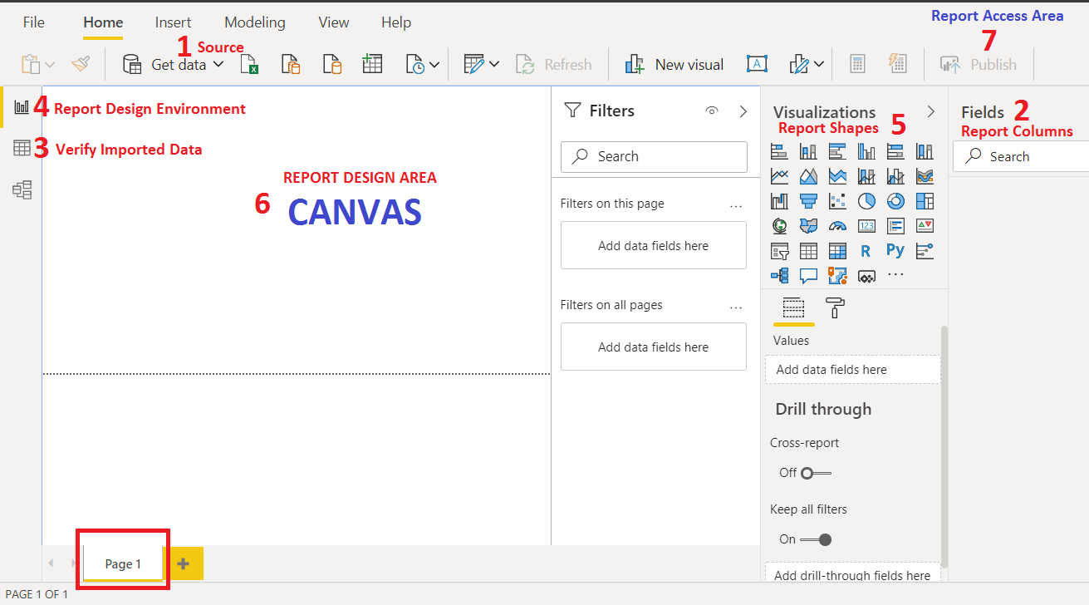

Solution:

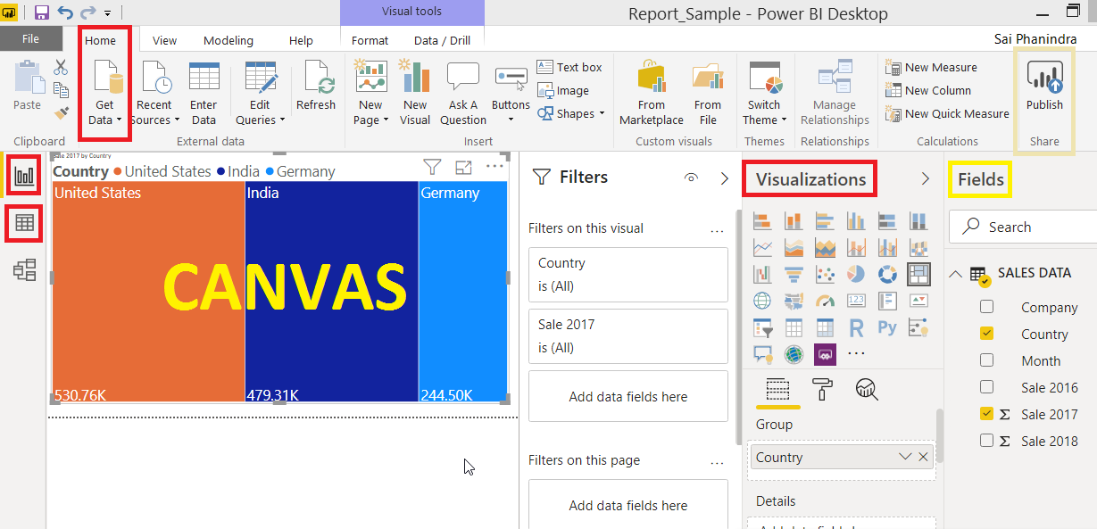

**Basic terminology for understanding the visuals [Example : Treemap, Table, Matrix, etc...] :**

Legend : to categorize or divide the visual into "data points"

data labels : summary values for each category. Ex: total sales @ country

tooltip : additional data we see when hover mouse on a data point.

focus mode **:** this property is used to zoom a pirticular visual.